Verify and Change the following browser settings using Tools => Internet Options => Security tab.

- Click on Trusted sites, then press Sites button and add https://ariadne.uchicago.edu.

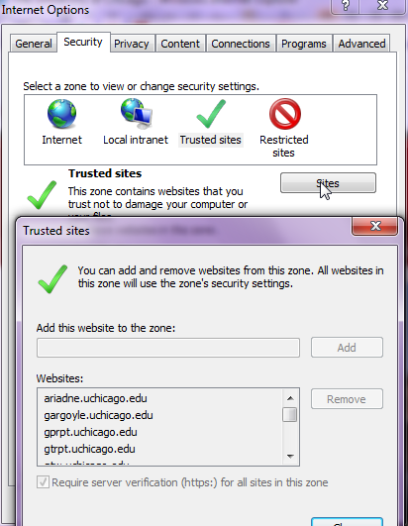

- Verify that the Popup blocker exceptions are enabled for the following website and is listed in the Allowed sites list.

ariadne.uchicago.edu
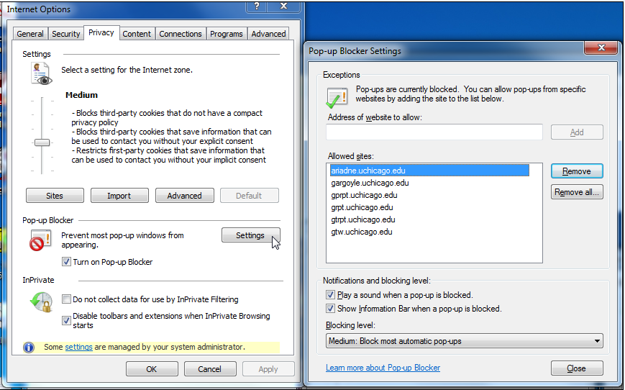

- Ensure that the security level settings for the ‘Internet sites’ zone are customized as shown below. ( click on ‘CUSTOM LEVEL’ button)

- Automatic Prompting for ActiveX controls to Enable.
- File download to Enable

- Close browser complete after changes are made and re-open browser.

Note: If you are still having problems after the above settings, then you can compare
the settings on the screen shots below to see that your settings are the same.

Screen Prints:
Please see below the I.E 8.0 Internet security settings after customizing default
