

The University of Chicago
Structure Cabling System for Telecommunications Systems

Guidelines and Specifications
Updated 5/11/2022

Table of Contents
Table of Contents 2
1. Introduction 7
2. Planning and Design 7
2.1 Services Requiring Voice or Data Connectivity: 7
2.2 Roles and Responsibilities 8
2.2.1 The Project Responsibilities 8
2.2.2 ITS Responsibilities 9
2.3 Related Documents and Drawings 9
2.4 Substitutions 10
3. Communications Infrastructure Budget 10
3.1 Telecommunication network budget 13
1.2 Pre-Installation Meeting 13
4. Pathways 14
1.3 Outside infrastructure 14
1.4 Riser Conduits 17
1.5 Horizontal Distribution System 18
1.6 Telecommunications Outlet (TO) 20
5. Telecommunication Room Design and Specifications 23
1.7 Types of Telecommunication Rooms: 23
1.8 Entrance Facility (EF) 23
1.9 Main Telecommunications Room (MTR) 24
1.10 Telecommunication Room (TR) 27
1.11 Power requirements: 29
1.11.1 Entrance Facility (EF) Room 30
1.11.2 Main Telecommunications Room (MTR) 30
1.11.3 Telecommunications Room (TR) 30
1.11.4 Buildings requiring UPS power: 31
6. Structure Cable System 32
1.12 Manufacturers 32
1.13 Copper Cabling System 33
1.14 Telecommunication Outlet (TO) 33
1.15 Wireless Access Point Cabling 34
7. Communications Backbone cabling 36
1.16 Copper Backbone: 36
1.17 Fiber Optic Backbone Cable 36
1.18 Backbone Cable Testing 37
1.19 Backbone terminations 38
8. Labeling 39
1.20 Client Location Jack Labeling 39
1.21 TR Location Panel Labeling 42
9. Telecommunications Rooms fittings 43
10. Fire Stopping 45
11. Grounding and Bonding for Communications Systems 46
12. Emergency Blue Light phones: 49
1.22 Approved Manufacture: 49
1.23 Approved enclosures: 49
1.24 Basic installation of CB 1-S 50
13. Special Applications: 51
14. Charts and Diagrams 51
1.25 Conduit and cable tray fill charts: 51
1.26 Standard MTR Layout 53
53
1.27 Standards TR Layout 53
53
1.28 Interior Ceiling mount wireless access point detail 54
54
1.29 Buildings Grounding and Bonding: 54
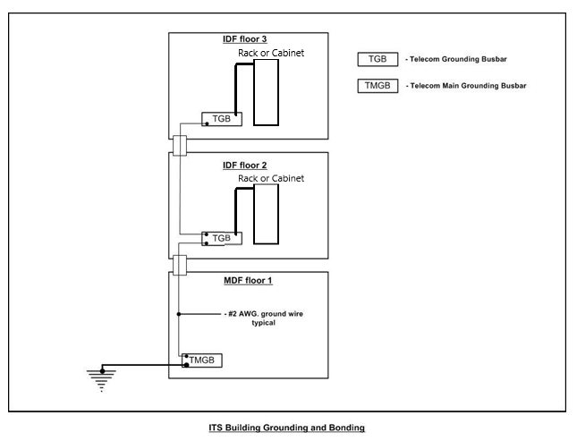 54
1.30 Equipment Rack Grounding and Bonding: 55
1.31 Emergency Blue Light Phone tower installation CB 1-S 56
1.32 Emergency Blue Light Phone tower installation CB 1-S 57
1.33 Construction As-Built Labeling example: 58
15. Approved Manufacture and Material List 59

Introduction
The University of Chicago depends on a highly robust communications network infrastructure to accomplish the mission of the University. The communications infrastructure must be able to support administrative and research functions along with support systems such as Public Safety and Building Automation. Information Technology Services (ITS) is responsible for the installation and maintenance of this communications infrastructure.
Constant change in communications technology drives the specifications within this document. The communications infrastructure within a building represents a twenty-year investment. Within that infrastructure life cycle, communications and computing technology will go through several iterations that will continue to rely on the installed infrastructure. Other factors such as the constant reprogramming of space to meet the changing needs of the University are drivers that require us to build a high quality, highly flexible infrastructure.

Planning and Design
This document is published and maintained by Information Technology Services (ITS) and is intended to serve as a guide for architectural design pertaining to the telecommunications infrastructure at the University of Chicago. All construction and renovation projects on campus requiring communications services from ITS must include this document as part of the project’s scope of work. It contains a complete description of the University of Chicago’s Structured Cabling Specifications (SCS) and Standards. In some cases, these requirements are stated in general terms due to rapid changes in technology. Therefore, ITS staff must be actively involved in the review of the communications infrastructure design from inception through construction. ITS infrastructure group must approve all communications designs, drawings and any modifications to the specifications listed in the Structured Wiring Plan. The Facilities Services Project Manager shall schedule regular design meetings with ITS Communications Infrastructure representative, ITS Network Engineering representative, and the business owner(s) representative.
IT Services Contacts:
Patrick Hickey, RCDD
773.702.3161
Michael Williams
773 834-3296

Services Requiring Voice or Data Connectivity:
- There are several building services that require either voice or data communications. Below is a list of building services that require communications services and need to be included early on so that a complete list of all the necessary communications locations can be included in the cost and indicated on the drawings for installation.
    - Elevators
    - Building Automation Systems
    - Audio Visual (AV)
      - Video Conference
      - Projectors
      - AV Head End Equipment
    - Conference Phones
    - Fire Alarms
    - Security (Department of Safety and Security)
      - Video surveillance
      - Building access
      - Emergency Phones
    - Area of Rescue Assistance
      - For details on this, contact the University of Chicago’s ADA/Code Specialist.
    - Point of sales
    - Wall phones
    - University time clock system Employee swipe card

Roles and Responsibilities
The project will be responsible for all costs associated with the installation of the telecommunications infrastructure. This will also be including the re-routing of any existing infrastructure necessary to accommodate the project.

The Project Responsibilities
The Project will be responsible for the procurement and installation of the following support infrastructure:
  - All horizontal pathways including
    - Conduit
    - Junction boxes
    - Drywall Rings
    - Raceway
    - Cable Tray
    - Pull boxes
    - Approved fire rated EZ path
  - Telecommunications Rooms (TR) including
    - Power
    - Telcom Ground bus
    - Lighting
    - HVAC
    - Flooring
    - Card Access
  - Vertical Infrastructure
    - Vertical risers
    - Vertical pathways
    - Grounding
  - Building Entrance
    - Conduit sleeves
    - Pathway to Equipment Room (ER) or Telecommunication Room (TR)
    - Outside plant connectivity to existing ITS infrastructure
    - Protection of Outside plant cables
    - Outside plant connectivity for external service providers ITS will be responsible for procuring:
  - Material and labor for the installation of all horizontal and vertical communications cable to be used for connecting to the University’s voice or data network
  - Material and labor to build out the support infrastructure in all communications rooms
  - Material and labor to build out the copper and fiber optic vertical backbone infrastructure
  - Material and labor to build out the copper and fiber optic building service infrastructure
  - Material and labor to remove old communications cabling
  - Material and labor to reroute existing outside plant cable
  - Material and labor to reroute existing vertical communications infrastructure
  - Material and labor to install networking equipment and wireless devices

ITS Responsibilities
ITS will be responsible for selecting and managing the telecommunications preferred contractor and any coordination efforts with the general contractor or their subcontractors and in house PM (FSP). At the conclusion of the project all the above material and labor will be billed back to the project by ITS. On large projects, ITS will bill the project on an agreed upon schedule over the duration of the project. All field changes to the original scope of the project will be documented and submitted to the Facilities Services Project Manager for approval before any work is done.

Related Documents and Drawings
  - A project charter or SOW is required for all projects.
  - General Drawing Specifications: Detail and elevation drawings shall be D size (24” x 36”) with a minimum scale of 1/4” = 1’0" or larger. MTR, TR and other enlarged detail floor plan drawings shall be D size (24” x 36”) with a minimum scale of 1/4” = 1’0" or larger. Building composite floor plan drawings shall be D size (24” x 36”) with a minimum scale of 1/8” = 1’ 0”.
- Building composite floor plans: Provide building floor plans showing outlet locations and jack configuration, types of jacks, run distance for each jack cable, and cable routing/locations. Identify telecommunication outlets (TO’s) that, according to location and available pathway systems, require cable length greater not than allowed by standards.
- Telecommunications space plans/elevations: Include enlarged floor plans of TRs indicating layout of equipment and devices, including receptacles and grounding provisions. Submit detailed plan views elevations of telecommunications spaces showing racks, fiber shelves, copper patch panels, termination blocks, and cable paths.
- Logical Drawings: Provide logical riser or schematic drawings for all systems. Include schematic symbol key.
- The final Construction Documents shall include marked IT locations with the designated ITS labeling scheme (see section 8 on page 37 for labeling) with excel spreadsheet from the design team, contact ITS with questions (see example 14.9 on page 59).

Substitutions
- Substitution requests: Substitution requests will be considered only if submitted to Owner’s Representative not less than 7 working days prior to project bid date. Acceptance or rejection of proposed substitution is at Owner’s Representatives sole discretion. No exceptions. Requests for substitutions shall be considered not approved unless Owner’s Representative issues approval in writing.
- Rejection: For equipment, cabling, wiring, materials, and all other products indicated or specified as no substitutions or no alternates, Owner does not expect nor desire requests for substitutions and alternate products other than those specified. Owner reserves right for Owner’s Representative to reject proposed substitution requests and submissions of alternates without review or justification.

Communications Infrastructure Budget
- For IT Services to provide the Facilities Services Project Manager with a gross budget estimate for a project, ITS will need to be involved in the planning phase of the project, and at minimum, will need the following information:
- Work order with account number
- A completed ITS intake form
- The scope of the project
- Project time frame with milestones
- Business owner contact information
- Access to preliminary drawings
- Gross square footage of the building
- Number of expected occupants
- Types (lab’s, office, ETC) of spaces to be included in the building

- Working with the Facilities Services Project Manager, ITS will provide budget estimates for the communications cabling, infrastructure, and network equipment. These costs will include:
- Material and installation of the horizontal communications station cable
- Material and installation of the support infrastructure in all communications rooms
- Material and installation of the copper and fiber optic vertical backbone infrastructure.
- Material and installation of the copper and fiber optic building service infrastructure
- Labor to remove old communications cabling
- Material and labor to reroute existing outside plant cable
- Material and labor to reroute existing vertical communications infrastructure

- The Facilities Services Project Manager will be responsible for estimating the following infrastructure:
- All horizontal pathways, including
  - Conduit
  - Junction boxes
  - Drywall rings
  - Raceway
  - Cable tray
  - Pull boxes
  - Approved fire rated EZ Path sleeves
- Telecommunications Rooms, including
  - Power
  - Lighting
  - HVAC
  - Flooring
  - Access
- Vertical Infrastructure
  - Vertical risers pathways
- Building Entrance
  - Conduit sleeves
  - Pathway to MTR
  - Outside plant connectivity to existing ITS infrastructure
- All budget figures are subject to change as the project goes through all the design phases. The communications infrastructure budget should go through no fewer than three (3) reviews during the project’s design phases. Working with the Facilities Services Project Manager, ITS will define budgetary costs as the project evolves through each of the design phases. Depending on the project, a final budget should be in place after the 100% Construction Design (CD) phase of the project. When ITS receives the 100% construction drawings an RFP will be sent out by ITS to pre-qualified ITS vendors for the installation of the cable infrastructure and the build out of the telecommunication rooms. The 100% telecommunications drawings should be completed in accordance with CSI Division 27 specifications. These drawings shall be presented to ITS in Adobe PDF/ AutoCAD (.dwg) format and will illustrate the following:
- All telecommunications outlets (TO’s).
- All items listed in section 1.1 to accommodate building services.
- All telecommunications rooms (ER and TR).
- Size and quantity of Horizontal and vertical pathways.
- Building Entrances.
- Final room number designations.
- HVAC systems for all communications rooms.
- Power in all communications rooms.
- Wireless device locations.
- The telecommunications system herein specified provides for voice, data, wireless, video conference, audio visual and other University systems that require data communications (such as the Department of Safety and Security and Building Automation Systems) through twisted pair or fiber optic cable. The system shall provide acceptable outlets for any communications device that requires connection to the University of Chicago’s network to serve the general needs of the University.
- These specifications comply with the following national standards bodies:
- ANSI/NFPA 70 National Electrical Code with Indiana Amendments, latest edition
- BICSI (Building Industry Consulting Services International) CO-OSP Customer Owned Outside Plant Manual
- BICSI 14th Edition Telecommunications Distribution Methods Manual
- BICSI 5th Edition Customer Owned Outside Plant Design Manual
- FCC Rules and Regulations
- TIA 606-B Labeling standard’s
- J-STD-607-A Commercial Building Grounding (Earthing) and Bonding Requirements for Telecommunications
- NFPA 101: Life Safety Code
- TIA 568-C Commercial Building Telecommunications Cabling
- TIA 569-B Commercial Building Standard for Telecommunications Pathways and Spaces
- TIA 758-B Customer Owned Outside Plant Telecommunications Cabling Standard

3.1 Telecommunication Network Budget
- The project is responsible for all networking cost for new and renovation projects, ITS will procure and install all networking equipment needed for the project. This includes all network switching and routing equipment, wireless access points, firewall and security changes, and all fiber and copper patch cords.
- The project shall provide an account number for ITS to bill the networking equipment.
- For budget purposes ITS shall budget 60% activated Telecommunication Outlets including BAS, Alarms, and devices for Department of Safety and security.
- The project (FSP) PM shall approve of the ITS networking bill of materials (BOM) before ITS procures the networking equipment. A minimum of 4-6 weeks is required to order the necessary networking equipment.
- If additional equipment if required over and above the (1) active port per TO the project shall provide ITS with a change order ticket and approval for the cost of the additional networking equipment.
- ITS wireless engineer shall designate the necessary amount and location of wireless devices to accommodate 100% density in all common areas.
- The project shall provide ITS with a completed networking End User Requirements (EUR) doc with the following information:
  - Who is moving?
  - Where they are moving from and to.
  - All devices requiring network IP address
  - The IP address of all network devices to be installed
  - Mac addresses of all equipment to be installed.

3.2 Pre-Installation Meeting
- After award, convene a pre-installation meeting at least 14 calendar days prior to commencing related work. The meeting must be scheduled at least 14 days in advance. Require attendance of parties directly affecting work of this section, including other trades and utilities if necessary. Review conditions of operations, procedures, and coordination with related work.
- Tour, inspect, and discuss building conditions relating to telecommunications system cabling and equipment, ITS telecommunications system requirements, and coordination with existing conditions and other work.
- Review exact location of each item within building construction, casework, and fixtures, and their requirements.
- Inspect all telecommunication pathways to verify size and quantity to meet ITS standards.
- Review and finalize construction schedule related to telecommunications system and verify availability of materials, personnel, equipment, and facilities needed to make progress and avoid delays.
- Review cable routing and support provisions.

Pathways
  - This Standard provides generic requirements for telecommunications pathways and spaces. Included are separation and isolation considerations for operating environment compatibility, telecommunications facility diversification recommendations to ensure operation in catastrophic conditions, temperature and humidity requirements, and thermal characteristics of pathways. Architectural (e.g., room size and fire stopping) and environmental (e.g., HVAC, grounding and bonding, and electromagnetic noise reduction) design guidance is also provided.

Outside infrastructure
- Outdoor telecommunications pathways connect building, maintenance holes, and hand holds. These pathways are either underground or aerial. Underground is generally preferred over aerial because of aesthetics and security. Generally, underground duct banks are preferred over direct buried because of security, ease of future cable installation, and maintenance.
- IT Services and engineers must be contacted to determine the best cable distribution method along a proposed cable route. The methods used may be one or a combination of the following.
  - Underground cable in conduit
  - Directional boring
- Underground cable system consists of cables placed in buried conduits, using manholes and/or pull boxes in large runs. The conduit runs from the building entrance location to a maintains hole. IT Services recommends that all outside plant cabling be placed in conduits.
- Direct buried cable system is not an IT Services accepted distribution method.
- Aerial cable system installation is not an IT Services accepted distribution method.
- Conduit Types
  - Examples of conduit types include:
  - — EB-20 – For encasement in concrete.
  - — EB-35 – For encasement in concrete.
  - — DB-60 – For direct burial or encasement in concrete.
  - — DB-100 – For direct burial or encasement in concrete.
  - — DB-120 – For direct burial or encasement in concrete.
  - — Rigid Nonmetallic Conduit Schedule 40 – For direct burial or encasement in concrete.
  - — Rigid Nonmetallic Conduit Schedule 80 – For direct burial or encasement in concrete.
  - — Multiple Plastic Duct (MPD) – For direct burial or installation in conduit.
  - — Rigid Metallic Conduit – For direct burial or encasement in concrete.
  - — Intermediate Metallic Conduit – For direct burial or encasement in concrete.
  - — Fiberglass Duct – For direct burial or encasement in concrete.
  - — Inner duct Polyethylene (PE) – For direct burial or installation in conduit.
  - — Inner duct Polyvinyl Chloride (PVC) – For direct burial or installation in conduit
    - Underground Conduit Requirements
  - Underground cabling in conduit projects must be worked from engineering drawings approved by IT Services and Engineering.
  - All submitted drawings and documentation must include the following information.
- Submittals and/or details of a typical trench cross sections showing cable and duct locations in the trench, clearances from final grade, backfill materials and depths, pavement cutting information, and compacting requirements for both paved and unpaved areas.
- The project shall follow the City of Chicago Department of Transportation guidelines.
- Construction notes applicable to the work being performed.
- Scale drawings showing location ties to existing structures, cable, conduit, utility boxes, and any conflicting substructures and profile drawings of congested areas where vertical and horizontal separation from other utilities is critical during cutting and placing operations and any other areas as requested by IT Services.
- Legends explaining symbols of all relevant structures and work operations.
- Cable types counts, and directions of feed.
- Conduit types, dimensions, and wall-to-wall measurements when used with maintenance hole.
- All areas around the conduit entrances must be free of any construction, storage, or mechanical debris.
- Installation
  - The length of conduit between pulling points shall not exceed 600 ft. (183m).
  - Manufactured bends should be used whenever possible. No section of conduit shall contain more than two 90-degree bends, or equivalent between pull points.
  - Conduits should be installed such that a slope exists away from the building to allow for drainage and prevent the accumulation of water.
  - When conduits connect maintenance holes, a slope of .125 in per foot (10 mm per meter) should exits from the middle of the span to each maintenance hole.
  - Conduits must be buried at a minimum depth of 42 in. (45.7 cm).
  - Minimum of (4) 4” IMC conduits shall be installed from the nearest utility tunnel on outside of the building as shown on the Drawings. Terminate entrance conduits entering ER rooms from below grade to extend 4" above finished floor. Location of entrance conduits shall be within 12” of room corners.
  - Terminate entrance conduits entering ER rooms from above ceiling height to extend 4" below finished ceiling or 12” above cable tray.
  - Terminate entrance conduits entering an ER rooms from below ceiling height to extend 4" into the room.
  - Entrance conduits shall be continuous into the building and to the ER. Securely fasten all entrance conduits to the building to withstand any cable placing operation. Do not include more than two 90-degree bends between pulling points when installing entrance conduits.
  - On exterior wall penetrations, seal both sides of the wall around outside of conduit with hydraulic cement to prevent water from entering the building. Seal the inside of the conduit on both sides with conduit plugs, water plugs, or duct sealer to prevent water, vapors, or gases from entering the building.
  - If the entrance conduits exceed the 180 degree of total bends limitation, an appropriately sized junction box, maintenance hole, or hand hole is required.
  - As-built drawings of entrance conduit path required to be submitted to Owner’s Representative before covered with soil.
  - All conduit ends adjacent to the building must be flagged for easy identification.
  - All unused entrance conduits must be capped and installed with pull strings.
  - Warning tape color orange for the telecommunications cables containing metallic tracings must be placed a minimum of 18 inches above the buried conduits to minimize any chance of an accidental dig-up.
  - The following minimum vertical and horizontal separations that must be maintained between
telecommunications facilities and the other utilities sharing a common trench:
    - Power or other foreign conduits: 3” of concrete, 4” of masonry, or 12” of well-tamped earth.
    - Pipes such as gas, oil, water: 6” when crossing, 12” when parallel
    - Railways: 3’ below top of rails.
  - Conduit must be encased in concrete when the following conditions exist:
    - Minimum conduit depth cannot be attained
    - Conduit must pass under roads, driveways, railroad tracks, or when bend points are subject to movement.
  - Reinforcing bars and/or crutches within the concrete must be used at any location that is subject to potentially extreme stress.
  - The inside-the-building end of the conduit must be sealed to prevent rodents, water, or gases from entering the building.
  - All conduit penetration shall have a mechanical system that seals the annular space around the conduits that pass through concrete walls and floors. This is to provide protection from water and gas penetrating the foundation wall or floor.
  - All bends must be long, sweeping bends with a radius not less than 6 times the internal diameter of a conduit 2 inches or smaller, or 10 times the internal diameter of a conduit larger than 2 inches.
  - All open conduits must be provided with# 12 Tracer wire.
  - The minimum number of conduits standard for any installation of cable will be:
    - (3)-4” conduits, with mule tape.
  - All conduits containing inner ducts must be provided with #12 Tracer wire.

Riser Conduits
- Riser / vertical conduits shall be used to install backbone cabling between MTR and TR that are on separate floor.
  - Conduits or sleeves shall be positioned adjacent to a wall on which the backbone cable will be supported.
  - Minimum of (2) 4” conduits shall be installed between the MTR room and each TR room as shown on the Drawings.
  - Conduits entering MTR and TR rooms shall be reamed or bushed and terminated not more than 4" from entrance wall and within 12” of room corners.
  - Conduits entering MTR and TR rooms from below floor shall be terminated not more than 4" above finished floor.
  - Conduits for riser cables shall be continuous and separate from all other conduit or enclosed raceway systems. Do not include more than two 90-degree bends between pulling points when installing riser conduits. Where junction boxes are required, locate in accessible areas, such as above suspended ceilings in hallways.
  - Conduits shall not be less than 4" trade size and be equipped with a measured pull line at 12” increments rated at a minimum 1200-pound test.
  - Provide restorable fire stops inside and around conduits as recommended by UL1479 or ASTM E814 for all conduits penetrating fire-rated construction. Fire-rated construction to be verified with AHJ.
  - Provide an insulating press fit bushing on all telecommunications riser conduits. Bushings must be rated to be used in an environmental air handling space (Plenum).
    - Manufacturer of insulating bushing on all telecommunication conduits shall be Arlington or equal.
  - Riser conduits shall not be used for the distribution of horizontal cables.
  - Both ends of the conduit shall be grounded to the Telcom ground bus.

Horizontal Distribution System

- Install empty raceway system, including underfloor and overhead distribution system, fish wire, terminal cabinets, outlet boxes, floor boxes, pull boxes, cover plates, conduit, sleeves and caps, cable troughs, service poles, miscellaneous and positioning material to constitute complete system, as indicated for distribution of Telecommunications wiring which includes cables for Data, Voice, Video, Audio, Security, and future signal requirements.
  - Corridor Cable Tray System
    - “J-Hook” installation is not allowed under any circumstance for horizontal distribution systems.
    - ITS preferred horizontal distribution system is open cable tray in accessible hallway ceilings.
    - Complete wall mounted or suspended aluminum/metal cable tray system and necessary accessories shall be provided as shown on plans. Install entire cable tray system in accordance with manufacturer’s minimum installation practices and all local governing codes.
    - Coordinate installation of cable tray with other trades to allow a minimum of 12” above, 12” in front, and 12” below of clearance from piping, conduits, ductwork, etc. Allowance must be provided for access to the tray with reasonable room to work. Obstructions to the tray must be minimized and cannot block more than 6 feet of the tray at any point in the run.
    - Submittal drawings, in the form of 8 ½”x 11” catalog cut sheets, shall be provided for the following items: cable tray, fittings, accessories and load data.
    - Cable tray shall not be loaded beyond 60% of manufacturer’s recommended load capacity.
    - Where a new cable tray distribution system encounters a fire rated wall, install sufficient fire rated mechanical sleeves through the wall so cabling does not exceed 60% fill.
    - Where cable tray is exposed below ceiling, install the appropriate solid bottom inserts to conceal cables.
    - Install cable tray dropouts where large quantities of cables exit the distribution system.
    - Cable tray must be sized to facilitate sufficient growth capacity for migration cable plant to coexist in same tray as existing cable plant, wherever possible.
    - Fittings/Supports: Wire mesh cable tray fittings are field fabricated from straight tray sections, in accordance with manufacturer’s instructions. Supports will include the FAS (Fast Assembly System) where possible so that screws, bolts, and additional tools are not required for cable tray mounting; installation time is reduced; and tray path can adapt to installation obstacles without the need for additional parts. Place supports so that support span does not exceed that shown on the drawings.
    - FAS System support methods to mount from ceiling and wall structures with 1/4”, 3/8” or 1/2” threaded rod, if applicable.
    - Splices, including those approved for electrical continuity (bonding), as recommended by cable tray manufacturer. Select one of the following splicing methods, if applicable: a. UL Classified EDRN Fast Splice: No hardware required
    - UL Classified SWK Splice Washer Kit: Swaged set for splicing, turns, bends, tees
    - UL Classified ED Universal Splice Bar: Cut & bend to fit any configuration
    - Pre-click Splice: Bolted connection optional
    - UL Classified EDT Splice Plate: Bolted connection
    - UL Classified CE 25 & CE 30 Square Splice Washers: Use with EZ BN ¼” Nut & Bolt
    - UL Classified CE 40 Square Splice Washer: Use with EZ BN ¼” to splice trays on bends, adjustable tees
    - FASLock Splice: For sweeps and bends with tray 12” (300mm) and wider.
    - UL Classified EZ T 90 kit: For tees and 90s
    - UL Classified RADT90 kit: For 5-1/2” radius Tees and 90s
  - Accessories: As required to protect, support, and install a cable tray system. Select from the following accessories, if applicable:
    - Equipment Grounding Conductor Function & Grounding
    - UL Classified cable trays (including painted tray) may act as Equipment Grounding Conductors.
    - Use UL Classified splicing methods to ensure cable tray is electrically continuous and bonded as recommended.
    - Ground cable trays at end of continuous run.
    - Test cable tray system per NFPA70B, Chapter 18 to verify grounding less than 1 ohm.
    - Ground cable trays against fault current, noise, lightning, and electromagnetic interference by mounting grounding wire to each 10’ cable tray section with grounding clamp.

  - Corridor Conduit System
    - Main horizontal pathways in ceilings such as inaccessible or plenum will require a conduit system. A conduit system consists of installation from the applicable telecommunications space (TR or MTR) to telecommunications outlets (TO) in the floors, ceilings, walls, columns, and furniture.
    - The engineer/ designer shall consider the following for all conduit systems:
      - Best direct route with no single bend greater than 90 degree or aggregate of bends more than 180 degrees between pull boxes.
      - Contain no continuous section longer than 100’.
      - Be bonded to ground on one or both ends in accordance with NEC or local code requirements.
      - Withstand the environment to which they will be exposed
      - Runs more than 100’ shall have pull points or boxes inserted so that no segment between points/ boxes exceeds 100’.
      - De-Rating of Cable count due to bends in conduit:
        - A 15% de-rating factor shall be applied to the conduit fill factor for conduits with greater than a total of 180-degree bends or after (2) 90-degree bends.
    - Conduit size design consideration
      - Cable type
      - Conduit type
      - Conduit diameter
      - Conduit length
      - Conduit layout
      - Number and configuration of conduit bends
    - Conduit diameter size shall increase as the run approaches the MTR or TR from the furthest TO.

Telecommunications Outlet (TO)
- Telecommunications Outlet (TO) consists of one (1) 4-11/16" square by 2-1/8" deep flush mounted box. Each outlet box shall have a minimum of 1” dedicated EMT conduit extended into the hallway cable tray.
- Under no circumstances is “J-Hook” installation allowed.
  - Conduit’s size is as follows:
    - For Outlets with 3 or less cables, use a 1” EMT conduit
    - For Outlets with 3-6 cables, use a 1.25” EMT conduit
    - For all other sizes, calculate fill ratio at 40% for proper sized conduit
    - See chart 14.1 on page 51
  - The intent of the installation of the TOs which consist of the raceway is as follows:
    - Where ceilings are accessible, the raceway and entrance end fitting shall extend above the ceiling and the conduits installed above the ceiling in the room to the nearest hallway distribution system.
    - Where ceilings are partially accessible, or if the Drawings and/or Specifications indicate installation of access panels, the raceway shall extend above the ceiling and the conduits installed above the ceiling in the room to the nearest hallway distribution system.
    - Where ceilings are inaccessible or no ceilings exist, the raceway shall extend up as close to the ceiling as practical to allow installation of conduits as high as possible to the nearest hallway distribution system.
- Station Conduits:
  - Station conduit is defined as conduit that originates at the TO and rises within the walls or is exposed from a raceway and extends up into the drop ceiling or over to the hallway distribution system.
    - Provide station conduits from TOs to above the drop ceiling or extend over to the hallway distribution systems consisting of 1” EMT minimum or appropriate size as shown on the Drawings or as specified herein for installation of telecommunications cables.
    - Provide an insulating press fit bushing on all telecommunications conduits including interconnecting nipples and stub to distribution system. To prevent conflicts with other cables or conduits to cable tray, the conduit shall be stubbed not less than 6" above or below conduit/cable tray centerline. Where space permits, every effort shall be made to bend station conduits down such that the flow of installed cables promotes the minimum length back to the TR and the least amount of bends in the cables. Bushings must be rated to be used in an environmental air handling space (Plenum).
    - Provide measured pull line in 12” increments in each empty conduit to hallway distribution system.
    - Indelibly mark station conduit at hallway distribution end with Room # that conduit serves.
    - The use of 90-degree electrical pulling elbows is prohibited.
    - Do not include more than two 90-degree bends between pulling points when installing station conduit runs. If the path of the station conduits requires more than 180 degrees of total bends, installation of an appropriately sized junction box is required.
    - Place an appropriately sized junction box in each individual station conduit run that exceeds 100 feet in length.
    - The use of a third bend in a conduit is only acceptable if:
      - The total conduit run is reduced by 15%.
      - The conduit size is increased to the next trade size.
      - One of the bends is located within 12” of the cable feed end.
- Junction Box Requirements for Station Conduits
  - If the station conduit route exceeds the 180 degree of total bends limitation, an appropriately sized junction box is required within a straight section of the conduit run.
  - A junction box shall not be used in place of a bend. All junction boxes in station conduit paths shall be installed within a straight section of the conduit run.
- Wire Mold Solution
  - A metallic or plastic raceway providing telecommunication and electrical connectivity to the workstation planning and design shall consider the following guidelines:
  - The shared raceway shall provide a divided channel to separate telecommunication and electrical cabling from EMI.
  - The project shall provide all faceplates for the installed raceway.
  - In cases that Legrand / Wire mold 4000 series brand is installed, ITS faceplate shall be 4047C-1 series faceplate, single gang device.
  - The number and type of telecommunication outlets will determine the size and number of horizontal pathways needed to service the installed raceway.
  - The raceway and horizontal pathways shall not exceed the manufacture 40% fill ratio.
  - All 90-degree bends shall be sweeping bends, no sharp corners accepted.
  - All wire mold locations shall be reviewed and approved by IT Services before installation.
- Plenum Ceilings
  - Plenum rated communication and low voltage cable does not meet the City of Chicago fire code. The following specifications will default to nonplenum with its presence at any point in any project.
  - All cable shall be installed in conduit with plastic bushings. Cable tray shall be replaced with a conduit and pull box infrastructure.
  - TO conduits must be home run from each TR to an accessible pull box with no more than two (2) 90-degree bends.
  - Larger conduits shall be installed based on the 40 percent fill factor from the pull box to the IDF.
  - Conduit system shall be designed to accommodate future growth.
  - Pull boxes shall meet or exceed NEC standards, and must be accessible in the ceiling.
  - Conduits from the pull boxed to the IDF must be sized appropriately and are not to exceed more than 40% of capacity, refer to the conduit fill chart 14.1 on page 51.
- Drywall ceiling
  - The conduit shall be home run from each TO all the way to the basket tray/ ladder tray / pull box accessible in the corridor.
  - Basket tray shall not be installed in non-excisable Dry wall ceilings.
  - No conduit shall continue more than 100 feet without a pull box.

Telecommunication Room Design and Specifications

Types of Telecommunication Rooms:
  - Entrance Facility (EF)
  - Main Telecommunications Room (MTR)
  - Telecommunications Room (TR)

Entrance Facility (EF)
  - The EF room is for entities providing internet services and or access to the internet. In most cases internet service is provided by ITS and the rooms are combined, there are rare cases such as shared buildings, laboratories and hospitals that require separate rooms.
    - The EF room shall be adjacent to the MTR.
    - Conduit to ISP (internet service providers) infrastructure shall be routed to ISP outdoor infrastructure from this room.
    - A minimum of two (2) 4” conduits shall be stubbed and capped out of the building to the property line near the closest third-party communications service provider for future use. Exact location shall be coordinated and approved with IT Services
  - Major design factors of location and size of EF:
    - Space required for equipment
    - Future expansion
    - Access for both deliveries and installation
    - Proximity to electrical source and EMI
    - Access and proximity to telecommunication cabling pathways.
    - Floor loading
    - Project Manager.
  - ITS Project Manager shall recommend the number and location of communication racks and panels during the design phase of the project.
  - The door shall be a minimum of 36” wide and 84” high. The door shall be secured through the building access control system where available. If the building access control system is not available, then the room shall be keyed with the ITS standard Medeco cylinder.
  - To permit flexibility and accessibility of cabling pathways, suspended ceilings are not required in Telecommunication spaces unless needed per NEC standards.
  - Minimum ceiling height shall be 8’6”.
  - Coordinate the lighting layout with the rack equipment layout to ensure that lighting from the light fixtures is not obstructed. Exact location shall be coordinated and approved with ITS Project Manager.
  - (1) 4x8 ¾” fire rated plywood shall be installed on one wall. Exact location shall be coordinated and approved with IT Services Project Manager.
  - Floor shall be tiled or sealed per ITS approval.
  - Grounding bus detail rated at 100 amps with a minimum of five termination points and attached to the building ground. For further details, see the section 11 page 45 on Grounding and Bonding.
  - A dedicated 20-amp quad electrical outlet is required at all communication racks, exact location to be coordinated with ITS Project Manager.
  - A dedicated 30-amp L530 outlet is required at all communication racks, exact location to be coordinated with ITS Project Manager.
  - 20-amp convenience outlets are required on each wall within the EF .
  - All electrical outlets and panels shall be labeled with panel ID and circuit number, handwritten labels will not be accepted.
  - EF room housing electronics shall have a HVAC source to maintain continuous temperature 24 hours a day 365 days a year. The temperature inside the telecommunications rooms shall be maintained at 73+/-3F. The operating range of the room is between 70F and 80F. The relative humidity range shall be between 30% and 55%. The HVAC system will be installed by the project and maintained by the University of Chicago Facilities. Minimum requirements vary due to room size and amount of equipment installed in the room. Coordinate size of HVAC with ITS Project Manager.
  - The HVAC system shall be 100% dedicated to the EF room.
  - The HVAC system shall be monitored by the BAS system of the building.
  - Minimum of four (4) 4” conduits or EZ Path fire rated sleeves shall be installed between each EF and the MTR.
  - No water or other liquid-carrying piping shall be present in the ER. Examples include but are not limited to:
    - Plumbing including both supply and drain lines of any type.
    - Steam lines (this is an absolute must not)
    - Chilled Water
    - HVAC condensate lines
    - HVAC Duct work
  - The room directly above the EF cannot have any substantial plumbing or equipment that could potentially cause the flooding or water damage of the EF. Examples include, but are not limited to:
    - Rest rooms
    - Mechanical rooms

Main Telecommunications Room (MTR)
  - The MTR is the telecommunications building service entrance. It is the area where the demarcation between intra-building and inter-building cabling are connected. In most cases the MTR and the entrance facility (EF) are combined, provided the room shall be sized for both functions. The MTR shall meet the following requirements:
- Major design factors of location and size of MTR:
  - MTR shall NOT be located on a basement or sub level of any building
  - Space required for equipment
  - Future expansion
  - Access for both deliveries and installation
  - Proximity to electrical source and EMI
  - Access and proximity to telecommunication cabling pathways.
  - Floor loading
- Construction of the MTR must be completed before the installation of the communications cable can be started.
- A clear space with a minimum size of 20’ x 20’, sized according to the number of TR’s and the buildings square footage. Larger rooms may be required where the MTR, EF and third-party service providers share the space.
  - ITS Project Manager shall supply the number and location of communication racks and panels during the design phase of the project. A minimum designs hall be:
    - Quantity of (12) 19” aluminum racks
    - Quantity of (14) 10” vertical managers
      - (1) between each rack
      - (1) On the end of each rack.
    - See sample MTR 14.2 page 52
- A clear and accessible path of a minimum of 36” shall be in the front, rear and side of the installed racks.
- The door shall be a minimum of 36” wide and 84” high.
- The door shall be secured through the building access control system and the door shall be keyed with the ITS standard Medeco cylinder.
- To permit flexibility and accessibility of cabling pathways, suspended ceilings are not required in Telecommunication spaces unless needed per NEC standards.
- Minimum ceiling height shall be 8’6”.
- Coordinate the lighting layout with the rack equipment layout to ensure that lighting from the light fixtures is not obstructed. Exact location shall be coordinated and approved with IT Services Project Manager.
- Floor shall be tiled or sealed per ITS approval.
- Grounding bus detail rated at 100 amps with a minimum of 5 termination points and attached to the building ground. For further detail see the section 11 page 45 on Grounding and Bonding.
- MTR rooms housing electronics shall have a dedicated HVAC source to maintain continuous temperature 24 hours a day 365 days a year. The temperature inside the telecommunications rooms shall be maintained at 73+/-3F. The operating range of the room is between 70F and 80F. The relative humidity range shall be between 30% and 55%. The HVAC system will be installed by the project and maintained by the University of Chicago Facilities. Minimum requirements vary due to room size and amount of equipment installed in the room. Coordinate size of HVAC with ITS Project Manager.
- The HVAC system shall be monitored by the BAS system of the building.
- Minimum of four (4) 4” conduits or EZ Path fire rated sleeves shall be installed between each MTR and the TR.
- If the MTR is not serving as the entrance facility (EF) four (4) 4” conduits or EZ Path fire rated sleeves shall be installed connecting the entrance facility and the MTR.
- For grounding and bonding see our Grounding and Bonding section 11 on page 45.
  - No water or other liquid-carrying piping shall be present in the MTR. Examples include but are not limited to:
    - Plumbing including both supply and drain lines of any type.
    - Steam lines (this is an absolute must not)
  - Chilled Water
  - HVAC condensate lines
  - HVAC Duct work
- The room directly above the MTR cannot have any substantial plumbing or equipment that could potentially cause the flooding or water damage of the MTR. Examples include, but are not limited to:
  - Rest rooms
  - Mechanical rooms
- Power requirements:
  - All power requirements are subject to change and are highly dependent on the building requirements. All power requirements shall be coordinated with ITS PM prior to design and installation.
  - If the building will be on a generator all MTR outlets shall be on the generator.
  - (2) Dedicated 100amp 208-volt circuit breaker panel shall be installed within the MTR.
  - (2) Dedicated 20-amp quad electrical outlet is required at all communication racks, exact location to be coordinated with ITS Project Manager.
  - (2) Dedicated 30-amp L530 outlet is required at all communication racks, exact location to be coordinated with ITS Project Manager.
  - (2) 20-amp convenience outlets are required on each wall within the MTR.
  - (2) Power Distribution Units (PDU) are required at all racks containing networking equipment>
    - Each circuit shall be on redundant electrical feeds.
    - PDU’s shall be 208 volts
  - All electrical outlets and panels shall be labeled with panel ID and circuit number, handwritten labels will not be accepted.
  - See UPS section 5.6.4 page 28 for building that are installing a UPS system.

Telecommunication Room (TR)
  - The TR provides the connection between Telecommunication Outlet (TO) and the building backbone distribution pathway. The TR serves as a demarcation point for voice, data, video, BAS (Building Automation System), voice and fiber backbone, and in some cases security and access control.
  - Multiple TRs are required if the cable length between the TR and TO exceeds 90 meters or 295 feet or if the usable floor space to be served exceeds 929 square meters or 10,000 square feet.
  - In multi-story buildings, TRs on each floor should be located so that the TR’s physical footprint matches or is contained within or encompasses the physical footprint of the TR directly above and below, as applicable. This “stacking” minimizes the length of pathway required to connect TRs on adjacent floors.
  - Construction of the TR must be completed before the installation of the communications cable can be started.
  - A clear space with a minimum size of 10’x 12’ where the TR is shared space with security, access control and Building Automation Systems. Coordination between the Facilities Services Project Manager and ITS will be required to lay out the space
  - Final size and requirements may require a larger space based on the occupant’s requirements.
  - ITS Project Manager shall supply the number and location of communication racks and panels during the design phase of the project. A minimum designs hall be:
    - Quantity of (3) 19” aluminum racks
    - Quantity of (4) 10” vertical managers
      - (1) between each rack
      - (1) On the end of each rack.
    - See sample TR drawing 14.3 page 53
  - A clear and accessible path of a minimum of 36” shall be in the front, rear and side of the installed racks.
  - All TR locations are subject to ITS approval.
  - All TRs shall be accessible from a main hallway.
  - TRs on adjacent floors shall be stacked above one another.
  - The amount of equipment and racks will be determined by the quantity of information outlets and the square footage the TR is serving.
  - One TR can service 600 active data jacks; a larger TR will be required for larger quantity of active ports.
  - The maximum distance between the TR and the information outlet shall not exceed 295’ as measured per the pathway.
  - Additional TR’s may be required for those locations exceeding the 295’ limit.
  - Minimum amount of four (4) 4” ITS-approved fire rated system shall be installed to the horizontal raceway. Exact quantity and location shall be coordinated and approved with IT Services Project Manager.
  - Minimum of two (2) 4” conduits or ITS-approved fire rated system shall connect the MTR and the TR.
  - The door shall be a minimum of 36” wide and 84” high.
  - The door shall be secured through the building access control system the door shall be keyed to the ITS standard Medeco cylinder.
  - To permit flexibility and accessibility of cabling pathways, suspended ceilings are not required in Telecommunication spaces unless needed per NEC standards.
  - Minimum ceiling height shall be 8’6” and no ceiling is to be installed.
  - Coordinate the lighting layout with the rack equipment layout to ensure that lighting from the light fixtures is not obstructed. Exact location shall be coordinated and approved with IT Services Project Manager.
  - Floor shall be tiled or sealed per ITS approval.
  - Grounding bus detail rated at 100 amps with a minimum of 5 termination points and attached to the building ground. For further detail see the section on Grounding and Bonding.
  - Telecommunication rooms housing electronics shall have a dedicated HVAC source to maintain continuous temperature 24 hours a day 365 days a year. The temperature inside the telecommunications rooms shall be maintained at 73+/-3F. The operating range of the room is between 70F and 80F. The relative humidity range shall be between 30% and 55%. The HVAC system will be installed by the project and maintained by the University of Chicago Facilities Services. Minimum requirements vary due to room size and amount of equipment installed in the room. Coordinate size of HVAC with ITS Project Manager.
  - The HVAC system shall be monitored by the building BAS system.
  - Minimum of four (4) 4” conduits or EZ Path fire rate system shall be installed between each TR and the ER. Exact quantity and location shall be coordinated and approved with IT Services Project Manager.
  - For grounding and bonding see the Grounding and Bonding section 11 page 45.
  - No water or other liquid-carrying piping can be present in the TR. Examples include but are not limited to:
    - Plumbing, including both supply and drain lines of any type.
    - Steam lines (this is an absolute must not)
    - Chilled Water
    - HVAC condensate lines
    - HVAC Duct work
  - The room directly above the TR cannot have any substantial plumbing or equipment that could potentially cause the flooding of the TR. Examples include, but are not limited to:
    - Rest rooms
    - Mechanical rooms
  - Power requirements:
    - Buildings with generator power all TRs shall be on the backup generator.
    - Dedicated 60amp 208-volt circuit breaker panel shall be installed within the TR.
    - (2) Dedicated 20-amp quad electrical outlet is required at all communication racks, exact location to be coordinated with ITS Project Manager.
    - (2) Dedicated 30-amp L530 outlets is required at all communication racks, exact location to be coordinated with ITS Project Manager.
    - (1) 20-amp convenience outlets are required on each wall within the TR.
    - (2) Power Distribution Units (PDU) are required at all racks containing networking equipment>
      - Each circuit shall be on redundant electrical feeds.
      - PDU’s shall be 208 volts
    - All electrical outlets and panels shall be labeled with panel ID and circuit number, handwritten labels will not be accepted.
    - See UPS section 5.6.4 page 28 for building that are installing a UPS system.

Power requirements:
- IT Services does not require or maintain UPS units in telecommunications rooms. Users or building managers can request a UPS to be installed but the user or building is responsible for all costs pertaining to the maintenance or replacement of the UPS. Minimum power requirements are below for non-UPS and UPS buildings serving ITS equipment.
- Buildings without UPS power
  - At a minimum all IT electrical power shall be protected by a power conditioning device to correct one or more power abnormalities and can be divided into three major groups:
    - Devices that filter and or regulate the utility supplied power
      - Isolation transformer
      - Shielded isolation transformer
      - Harmonic mitigation transformer
      - Surge protective devices
      - Voltage regulators
      - Power conditions
      - Harmonic Filter

5.5.1 Entrance Facility (EF) Room
- If the building will be on a generator all EF outlets shall be on the generator.
- A dedicated 20-amp quad electrical outlet is required at the communication racks, exact location to be coordinated with ITS Project Manager.
- A dedicated 30-amp L530 outlet is required at the communication racks, exact location, and quantity to be coordinated with ITS Project Manager.
- 20-amp convenience outlets are required on each wall within the ISP.
- All electrical outlets and panels shall be labeled with panel ID and circuit number, handwritten labels will not be accepted.

5.5.2 Main Telecommunications Room (MTR)
- All power requirements are subject to change and are highly dependent on the building requirements. All power requirements shall be coordinated with ITS PM prior to design and installation.
- If the building will be on a generator all MTR outlets shall be on the generator.
- (1) Dedicated 100amp 208-volt circuit breaker panel shall be installed within the MTR.
- (4) Dedicated 20-amp quad electrical outlet is required at the communication racks, exact location to be coordinated with ITS Project Manager.
- (4) Dedicated 30-amp L530 outlet is required at the communication racks, exact location to be coordinated with ITS Project Manager.
- (1) 20-amp convenience outlets are required on each wall within the MTR.
- (2) Power Distribution Units (PDU) are required at all racks containing networking equipment
- Each circuit shall be on redundant electrical feeds.
- PDU’s shall be 208 volts
- All electrical outlets and panels shall be labeled with panel ID and circuit number, handwritten labels will not be accepted.
- See UPS section 5.6.4 page 28 for building that are installing a UPS system.

5.5.3 Telecommunications Room (TR)
- Buildings with generator power all TRs shall be on the backup generator.
- Dedicated 60amp 208-volt circuit breaker panel shall be installed within the IDF.
- (2) Dedicated 20-amp quad electrical outlet is required at the communication racks, exact location to be coordinated with ITS Project Manager.
- (2) Dedicated 30-amp L530 outlets is required at the communication racks, exact location to be coordinated with ITS Project Manager.
- (1) 20-amp convenience outlets are required on each wall within the TR.
- (2) Power Distribution Units (PDU) are required at all racks containing networking equipment.
- Each circuit shall be on redundant electrical feeds.
- PDU’s shall be 208 volts
- All electrical outlets and panels shall be labeled with panel ID and circuit number, handwritten labels will not be accepted.
- See UPS section for building that are installing a UPS system.

5.5.4 Buildings requiring UPS power:
- All buildings requiring UPS power shall be responsible for all costs pertaining to the maintenance or replacement of the UPS
- The UPS system shall be in the room adjacent to the MTR.
- Centralized building UPS system is the preferred UPS system of ITS, standalone units are not recommended.
- Top Design considerations:
  - Power environment
    - Single Phase
      - Three Phase
    - Installation environment
    - Power Load
    - Availability and Battery Runtime
      - UPS with no generator
      - UPS with generator
      - Redundant UPS
    - Scalability
    - Power Distribution
    - Manageability
    - Operations and maintenance
- The UPS shall be sized 2 times the total load
- The UPS shall have a minimum runtime 15-20 seconds for the generator start up time.
- All IT rooms HVAC systems shall be on the UPS and generator.
- UPS shall have a transfer switch
- Main Telecommunication Room (MTR)
  - (1) Dedicated 100amp 208-volt circuit breaker panel shall be installed within the MTR.
  - (4) Dedicated 20-amp quad electrical outlet is required at the communication racks, exact location to be coordinated with ITS Project Manager.
  - (4) Dedicated 30-amp L530 outlet is required at the communication racks, exact location to be coordinated with ITS Project Manager.
  - (1) 20-amp convenience outlets are required on each wall within the MTR.
  - (2) Power Distribution Units (PDU) are required at all racks containing networking equipment.
    - Telecommunications Room (TR)
      - (1) Dedicated 100amp 208-volt circuit breaker panel shall be installed within the MTR.
      - (2) Dedicated 20-amp quad electrical outlet is required at the communication racks, exact location to be coordinated with ITS Project Manager.
      - (2) Dedicated 30-amp L530 outlet is required at the communication racks, exact location to be coordinated with ITS Project Manager.
      - (1) 20-amp convenience outlets are required on each wall within the MTR.
      - (2) Power Distribution Units (PDU) are required at all racks containing networking equipment>

Structure Cable System
- Structure Cable System (SCS) system supporting telecommunications systems shall comply with detailed specifications in this section and shall consist of cabling that may include data backbone optical fiber cables, data backbone copper cables, voice backbone copper cables, patch panels, connecting hardware, horizontal data copper cables, and jacks at TOs for voice, data, and telecommunications system services. Locations of equipment shall be as indicated on drawings, unless directed otherwise by Owner’s Representative.

Manufacturers
- The basis for the design specifications defined within this document is the primarily the CommScope SYSTIMAX family of products. Any deviation or substitutions offered as part of this specification must be pre-approved by the owner or owners’ representative. Any submittals in response to any part of this specification that do not meet the product requirements as defined, may be rejected without further consideration, or may cause monetary charges to be incurred by the submitter.
- The SCS shall provide a certified system will support the applications for which it is designed, during the 25-year warrantee of the certified system by CommScope.
- General Requirements:
  - Provide installation testing of equipment where required by manufacturer’s installation instructions.
  - Provide complete end-to-end testing for all copper and fiber optic systems/channels based on latest applicable standards. Document all testing and submit with final as-built submittal package
  - For all controls and operating equipment, submit equipment/systems to at least three complete operational sequences, in which all equipment operations are tested, observed, and verified.
  - For all controls and operating equipment, submit equipment/systems to at least three complete operational sequences, in which all equipment operations are tested, observed, and verified.

Copper Cabling System
- Copper cabling shall be tested and certified after installation as follows and as required for cable manufacturer’s warranty. Twisted-pair copper cable channels shall be tested for continuity as specified below, presence of ac/dc voltage, and performance. All cabling shall be tested for conformance to horizontal cable specifications as outlined herein and shall be tested according to test set manufacturer’s instructions utilizing latest firmware and software. Testing shall include all electrical parameters as specified under Product. All cables and termination hardware shall be 100 percent tested by installation contractor for defects in installation and to verify cable performance under installed conditions. Contractor shall verify all conductors of each installed cable useable prior to system acceptance. All cables shall be tested according to contract documents, manufacturer’s warranty provisions, and best industry practices. If any of these are in conflict, Contractor shall comply with most stringent requirements. All defects in cabling system installation shall be repaired or replaced to ensure 100 percent useable conductors in all cables installed, at no additional cost to Owner.

Telecommunication Outlet (TO)
  - The installation telecommunication outlet (TO) be mandatory for all new and renovated University buildings to comply with industry standards and to provide the University with a consistent and sustainable infrastructure.
    - ITS has chosen Category 6A cable as its standard for Telecommunication Outlets (TO) and Cat 6 A for wireless access point locations
    - CommScope SYSTIMAX 1091B WHT C6A 4/23Category Category 6A U/UTP, non- plenum, 4 pair cable .31 OD. 760107144 | 1091B WHT C6A 4/23 U/UTP W1000
    - Security cabling such as cameras and control equipment (2) blue cables 760107094 | 1091B BLU C6A 4/23 U/UTP W1000
    - Wireless information outlet shall have two (2) category 6A cables installed. Both cables shall be yellow in color. 760107151 | 1091B YEL C6A 4/23 U/UTP W1000
  - Telecommunication outlet shall have two (2) category 6A cables installed. Both cables shall be white in color. 760107144 | 1091B WHT C6A 4/23 U/UTP W1000
  - Security (DSS) cabling such as cameras and control equipment (2) blue cables 760107094 | 1091B BLU C6A 4/23 U/UTP W1000

  - Wireless information outlet shall have two (2) category 6A cables installed. Both cables shall be yellow in color. 760107151 | 1091B YEL C6A 4/23 U/UTP W1000
  - Category 6A shall be terminated on Systimax category 6A 8 position 568B/ RJ45 jacks, gray in color, 760092437 | MGS600-270
  - Category 6A telecommunications outlet faceplate shall be White 2 port, unless otherwise stated by design team to match décor. 108168469 | M12L-262
  - Category 6A telecommunication Room (TR) end will be terminated on a category 6A RJ45 Systimax patch panel. 760152595 | 360-IPR-1100-E-GS6-2U-48
  - All station cable will be secured and dressed in Velcro strapping; no cable ties allowed.
  - Do not install compressed, kinked, scored, deformed, or abraded cable, or allow such damage to occur.

Wireless Access Point Cabling
  - ITS is responsible for the installation and maintenance of all 802.11AC wireless access points at the University of Chicago. The project is responsible for the installation of the horizontal infrastructure and cable necessary to support the wireless access points. The total number of access points and their locations cannot be finalized until a wireless survey is done. Wireless AP placement is deployed based upon user density not coverage, ITS plans for 100% coverage in all common areas. In addition to providing general coverage, special considerations need to be made in large public areas, classrooms, and conference rooms. Use the following chart to estimate the number of wireless locations necessary to provide coverage in these areas.
  - Minimum Signal RSSI
    - -65 DBM by at least two access points at any given location within the coverage areas; this minimum RSSI must be based on a 5GHz band coverage.
  - High Density Locations
    - A high client density location is defined as 50 or more devices in the same space. Calculating the number of APs in a high-density location is based on 2.5 devices per occupant, example conference room occupancy is 100 persons, 100x2.5 = 250 devices would require 5 AP’s. The wireless engineer will identify and calculate the high-density locations. The minimum RSSI may not be enough to provide the necessary Wi-Fi capacity / bandwidth, in such locations we plan for maximum of 50 wireless devices per access point, with the same standard of 2.5 devices per client.

Classroom / Conference Rooms Access Points
Number of Seats | Number of Access Points
Up to 25 | 1
26 to 50 | 2
51 to 75 | 3
- to 100 | 4

- Infrastructure required:
    - Each wireless information outlet shall have two (2) category 6A cables installed.
    - Category 6A wireless information outlet shall have two (2) category 6A cables installed. Both cables shall be yellow in color. 760107151 | 1091B YEL C6A 4/23 U/UTP W1000
    - Category 6A telecommunication outlet shall be terminated on Systimax category 6A 8 position 568B/ RJ45 jacks, yellow in color, 760092387 / MGS600-123Category 6A telecommunication Room (TR) end will be terminated on a category 6A RJ45 CommScope patch panel. 760152595 | 360-IPR-1100-E-GS6-2U-48
    - All wireless access point locations shall have a minimum of (1)-1” dedicated conduit servicing it to the basket tray.
    - In buildings that have dropped lay in ceilings the wireless location will be installed above the ceiling in a deep 4-11/16” x 4-11/16” box with a single gang trim ring.
    - In buildings with plenum ceilings the wireless locations will be terminated as described in section 4.5 page 19 in the ceiling flush with the finished ceiling height.
    - Installations in areas with nonstandard ceiling heights need to be coordinated with IT Services Wireless Engineer.
- Approved manufacture
  - Aruba
    - Model 515
    - Model 514
    - Model 303H
    - Model 505H

Communications Backbone cabling

Copper Backbone:
- Intra-Building Copper Backbone for Analog/Voice only
  - All cable shall be listed for use per the National Electrical Code (NFPA-70).
    - Cable shall meet one of the following, per bid document:
    - UL-listed CMR cable: Solid copper conductors with high-density polyolefin insulation and overall low smoke PVC jacket to achieve riser (i.e., non-plenum) rating by UL standards
    - Cable shall meet the requirement of ANSI/TIA-568 series Standards for Category 3 performance.
    - All TRs shall have a minimum of (1) 25 pair ARMM from the building MTR
    - Approved Manufacturer:
      - CommScope: 1010A SLT 25/24 R1000 (9-57242-1) 25 Pair Riser Rated
- Inter-Building Copper Backbone for Analog/Voice only
  - All cable shall be manufactured and constructed for use in the Outside Plant Environment.
  - Cable shall meet the requirement of TIA-568 series Standards for Category 3 performance
  - Approved Manufacturer:
      - CommScope: 1010A SLT 25/24 R1000 (9-57242-1) 25 Pair Riser Rated
- Building entrance protection
  - Building entrance protection for copper cabling shall be installed utilizing a two (2) foot fuse link between outside plant cable plant splice and the protector module with IDC-type input and output terminals, 100 pair-pair capacity and female mounting base, equipped with 230-volt solid-state protector modules. Sufficient protector modules shall be provided to completely populate all building entrance terminals.
- Voice backbone cables
  - Voice backbone cables shall have a minimum 10-foot service loop when terminated in the MTR and TR, and at any splice points in telecommunications manholes.

Fiber Optic Backbone Cable
- Cables shall be designed for Point-to-Point applications and shall provide a high level of protection for optical fiber installed in building applications.
- Intra Building Backbone (ISP)
  - All TRs shall be services with a minimum of (1) 24 strand Single-mode fiber optic cable and shall route point to point to building MTR with no splices.
  - Indoor Armored Riser Rated Tight Buffer - UL-listed OFCR: Tight buffer optical fibers, aramid strength yarn, a riser-rated jacket, aluminum interlocking armor with an overall riser-rated sheath jacket to provide additional protection and security.
  - Approved manufactures:
    - CommScope: 760127373 | R-024-DZ-8W-FSUYL
- Inter Building Stranded Backbone (OSP)
  - Indoor/Outdoor Cables - All cable shall be listed for use indoors per the National Electrical Code (NFPA-70) and shall meet both of the following, per bid document.
    - Indoor Riser Rated Tight Buffer - UL-listed OFNR: Tight buffer optical fibers, aramid strength yarn, and riser-rated outer jacket.
    - Indoor Low Smoke/Zero Halogen Riser Rated Tight Buffer UL-listed OFN(LS) cable: Solid copper conductors with non-halogen HDPE insulation and low smoke, zero halogen, compound jacket to achieve LSZH rating
  - All inter building fiber optic cables shall be 48 strand single mode fiber, point to point with no splices from the building MTR to ITS main network distribution. ITS project management team shall determine exact locations.
  - Approved manufacture:
    - CommScope: 760090309 | Z-048-DS-8W-FMUBK/C
- Installation
  - General - Inter and Intra Building Fiber Backbone Cable
    - Contractor shall comply applicable codes, standards and with all local codes and requirements. It is the responsibility of the contractor to identify and adhere to any unique codes or requirements governed by the region where the work is to be performed.
    - Provide all necessary products for installation of Fiber Backbone cablings to include cable attachments, etc.
    - Backbone cable shall be installed following industry standard practices.
    - Contractor shall not exceed the maximum pulling tension or the minimum bending radius for fiber cables per manufacturer’s specifications.
    - All installations shall comply with:
      - ANSI/TIA-568 Series Commercial Building Telecommunications Cabling Standard
      - ANSI/TIA-569 Telecommunications Pathways and Spaces
      - ANSI/TIA-606 Administration Standard for the Telecommunications Infrastructure
      - ANSI-J-STD-607 Joint Standard for Commercial Building Grounding (Earthing) and Bonding Requirements for Telecommunications
      - BICSI Telecommunications Distribution Methods Manual NFPA 70 National Electric Code
      - Outside Plant Design reference manual (OSPDRM) 6th edition

Backbone Cable Testing
- Complete end-to-end test results for all Fiber Optic cables installed are required.
- All fiber optic cable must be visually inspected and optically tested on the reel upon delivery to the installation site. Using an Optical Time Domain Reflectometer (OTDR), an access jumper with like fiber, a pigtail, and a mechanical splice, all fibers shall be tested for continuity and attenuation.
- Testing for continuity and attenuation on the reel must confirm factory specifications to ensure that the fiber optic cable was not damaged during shipment. The test results must match the results of the factory-attached tag on the reel, or the fiber shall not be used. Reel data sheet must be provided showing test results.
- End to end (bi-directional) test measurements shall be provided for single-mode and multimode fibers (two wavelengths per test are required). Test results must be submitted for review as part of the installation inspection requirements. Test results shall be in paper form and electronic form and must contain the names and signatures of the technicians performing the tests.
- Testing shall be performed on 100% of the fibers in the completed end-to-end system. TIA-568 provides the technical criteria and formulae to be used in fiber optic testing. Note however, that all UH fiber must be tested, rated, and guaranteed for Ethernet Giga SPEED 1000B-X performance.
- Additionally, all fiber optic cable links must pass all installation and performance tests both recommended and mandated by the cable manufacturer.
- The Owner is to be notified at least 24 hours prior to testing to allow observation at the Owner's discretion. If the Owner confirms his intention to observe, a reasonable starting time shall be agreed upon. Should the Owner not be present at the scheduled commencement time, the Contractor may begin testing as scheduled.
- Testing Format: Test Results must be submitted in two (2) formats. First, must be original file(s) downloaded from tester. Second, the file must be cohesively placed in Excel format with the following fields:
- ER/TR RM # / RM # of drop / Port # / all relevant test information in as many fields as necessary.
- 9. All test results are to be recorded and submitted to the Owner.

Backbone terminations
- All copper backbone cables shall be terminated on one of the following approved termination blocks:
  - CommScope 24 port patch panel: 760182907 | 1100-U-PS-24
  - CommScope 48 port patch panel: 760182915 | 1100-U-PS-48
  - CommScope 110Connect XC System Copper Wiring Block Kit, UTP term., 100-pair, 5-pair connecting blocks 569440-1
- The termination style depends on each building requirements the IT project manager shall specify the termination style for each building.
- All fiber optic termination shall be fusion splices.
- All fiber optic termination shall be SC APC (angle polish)
- Approved fiber optic terminations and houses are:
  - CommScope Tera SPEED® Splicing cassette, 12SC APC, 900μm: 760222604 | PNL-CS-12SAW-PT
  - CommScope Standard Density 4U sliding Panel, accepts (12) LGX/1000 style splice cassettes, modules or panels, providing up to 144 duplex LC ports 760231464 | SD-4U
  - CommScope Standard Density 1U sliding Panel, accepts (3) LGX/1000 style splice cassettes, modules or panels, providing up to 36 duplex LC ports 760231449 | SD-1U

Labeling
- The purpose of this section is to clearly define the labeling nomenclature to be implemented within new construction and renovation projects at both client jack locations as well as TR patch panels. This is to allow clear and concise labeling templates for installers.

Client Location Jack Labeling
Diagram 1 - Vertical Orientation

Diagram 2 - Horizontal Orientation

  - “U” upper label compartment.
  - Used to identify a standard jack id room, direction, type, and cardinality. All labels will be machine printed, bold font at the highest point that can fit all characters legibly and centered. All upper labeling should follow the following template:
<Room number><direction><type><cardinality>
<Room number> will be obtained from the current set of drawing provided by the project. If the main room has adjacent suites, this additional criterion is captured at the room number level
<Hall> in some instances, a jack will be in the halls or corridor. For these
Instances the word “hall” is placed as per the below template within the upper labeling compartment:
<Room number (of closest room)><hall><direction><type><cardinality>
<w> in some instances jacks are allocated for “wall phone” positions. For these instances a W is placed as per the below template within the upper labeling compartment:
<Room number (of closest room)>< direction><type><w><cardinality>
<direction> will be “N”, “S”, “E”, “W”,” CF”, “CC”
- N-North
- S-South
- E-East
- W-West
- CF-Center Floor
- CC-Center Ceiling
<Type> will be “B” for baseboard jacks
<Cardinality> will be the number of the wall plate on the wall, such as “1”, “2”, etc. Numbering will start on the left end of the wall and proceed clockwise until wall ends
*There may be data on some specialty jacks.
  - “L” lower label compartment.
Used to identify the room number of the TR for which the wall plate is pulled. This is particularly important in the middle of each floor, where some areas will have cabling that terminates in both TRs’, due to cabling length restrictions. All lower labeling should follow the following template:
<TR> <TR number>
<TR> First type the characters “TR”
<TR number> will be the actual room number of the relevant TR
  - Sample Scenarios (see diagram below)
  - Room: 122 Direction: West
  - Cardinality 1st jack position (left most jack on West wall)
  - U: 122WB1
  - L: TR 125
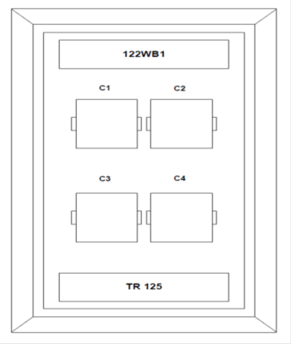

TR Location Panel Labeling
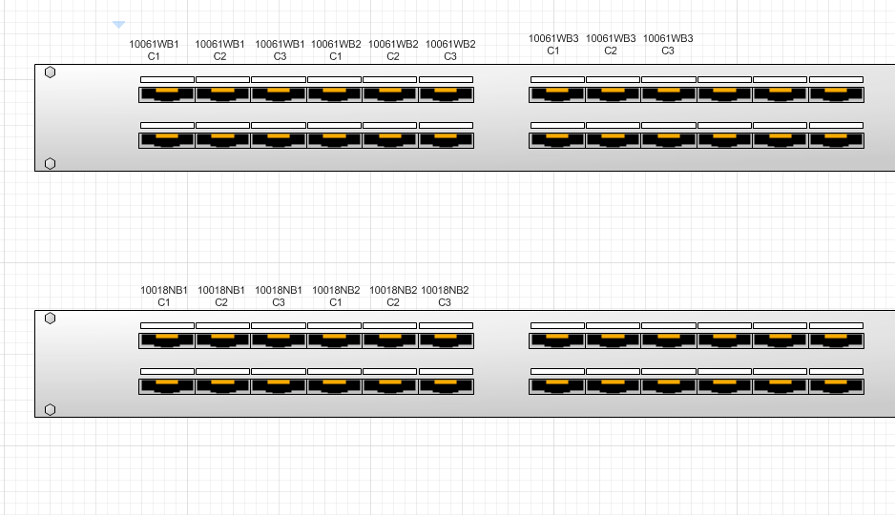
- All labels will be machine printed, bold font at the highest point that can fit all characters legibly and centered. Panel labeling should use the following template (template better depicted in Diagram 3 – Patch Panel Visio Diagram):
<Room number><direction><type><cardinality>
- <Room number> will be obtained from the current set of projects provided drawings. If the main room has adjacent suites, this additional criterion is captured at the room number level
- <Hall> in some instances, a jack will be in the halls or corridor. For these instances, the word “hall” is placed as per the below template within the upper labeling compartment:
- <Room number (of closest room)><hall><direction><type><cardinality>

Telecommunications Rooms fittings
- This section includes the minimum requirements for the equipment and cable installations in communications equipment rooms (Telecommunications Closets).
- Included in this section are the minimum composition requirements and installation methods for Communication Racks and Rack Cable Management.
- Racks
  - Racks shall be manufactured from aluminum and/or steel extrusion.
  - Each rack will have two L-shaped top angles, two L-shaped base angles and two C-shaped equipment-mounting channels. The rack will assemble with nut and bolt hardware. The base angles will be pre-punched for attachment to the floor.
  - Equipment mounting channels will be punched on the front and rear flange with the EIA-310 Universal Mounting hole pattern.
    - Aluminum Racks will be threaded with 12-24 roll-formed threads and will include 40 each combination pan heads, pilot point mounting screws.
  - The rack will include assembly and equipment-mounting hardware.
  - The rack will be rated:
    - Two Post Racks: 1,000 lb. (453.6 kg) of equipment
    - Four Post Racks: 2,000 lb. (907.2 kg) of equipment
    - The rack will be UL Listed
    - When assembled with top and bottom angles, equipment-mounting channels will be spaced to allow attachment of 19” EIA rack-mount equipment.
  - 45U - 7ft (2134 mm) H x 3in (76 mm) Channel x 19in (482.6 mm) Equipment Rack
    - Rack is to provide 45 rack-mount spaces in a “7-foot rack” for equipment. Each mounting space will be marked and numbered on the mounting channel.
    - For the "7-foot rack”, the assembled rack will measure 84" (2133.6 mm) high, 20.4" (518 mm) wide and 15" (381 mm) deep. The sides (webs) of the equipment-mounting channels will be punched to allow attachment of vertical cable managers along the sides of the rack or for rack-to-rack baying.
    - 3. Finish shall epoxy-polyester hybrid powder coat in the color as specified below.
    - Approved Manufacturer:
      - CommScope: 760082495 | RK6-45A
      - IMS Amco Titan TCMR-45U-16

- Rack Cable Management
  - Vertical cable management shall have doors that are lightweight, sturdy, and be available in different sizes to allow flexibility in design.
  - The cable management system shall have a C-Channel bracket that allows for easy access to the cable trough.
  - The vertical cable management system shall allow tool-less installation of Cable Spool.
  - Doors shall come standard with on all cable management and be available in both single and double-sided configurations.
  - The door shall have dual hinge design that can be opened to the right or left.
  - The door latching mechanism shall have an easy closing feature.
  - The door shall have one point removal and installation process for door.
  - Horizontal wire managers: The door shall have horizontal cover hinges up or down and be lockable into position with cylindrical finger ends for easy snap on installation
  - The door shall have a recessed handle to eliminate snag potential for clothes and arms.
  - The Horizontal cable management system shall have an open back on 2U horizontal troughs for easy pass-through of cables
  - Vertical Cable Management for Racks
    - The vertical cable management kits are installed on the side of a 19-inch or 23-inch (483 or 584 mm) wide industry standard rack.
    - The door(s) shall be designed to provide a concealed vertical space for organizing patch cables.
    - Cable spools shall be used to organize longer patch cable lengths.
    - Cable managers are to be matched to the cable rack and shall be double-sided 10” wide with doors.
    - Approved Manufacturer:
      - CommScope 760244781 | VCM-DS-84-10B
      - IMS Amco Titan: TCMR-xxU-10
  - Horizontal Cable Management for Racks
    - The horizontal cable management kits are installed on a 19-inch (483 mm) wide industry standard rack above or below panels to organize patch cables.
    - The kits shall be available in a single-sided and double-sided configuration, and in a 2U-height.
    - The units shall include covers that can be opened from the top, the bottom, or removed altogether.
    - The cover hinges shall be designed to hold the cover open from the top or bottom to facilitate faster cabling.
    - The 2U and 3U cable managers shall have a pass-through feature allowing access to and from the rear for additional cable routing.
    - The depth of the units shall be
      - single-sided: 5-1/2 inches (140 mm) deep from front to back with the cover closed
    - Approved Manufacturer:
      - CommScope HTK-19-SS-2U (760072959) 2RU Horizontal Cable Management

Fire Stopping
- All data, video, and communications cable bundles shall utilize an enclosed fire rated pathway device wherever said cables penetrate rated walls. The fire-rated pathway shall contain a built-in fire sealing system sufficient to maintain the hourly fire rating of the barrier being penetrated. The self-contained sealing system shall automatically adjust to the installed cable loading and shall permit cables to be installed, removed, or retrofitted without the need to adjust, remove ore reinstall fire stop materials. The pathway shall be UL Classified and/or FM Systems Approved and tested to the requirements of ASTM E814 (UL1479). The University of Chicago approved system that meets these specifications is:
Specified Technologies Inc.
EZ-Path system
https://www.stifirestop.com

- Fire Rated Wiring Device System
  - All cable penetrations through floors or fire rated walls shall utilize fire rated device systems that shall be approved by ITS.
  - All devices shall be heavy-duty specification grade an in tumescent insert material allowing for 0-100 % visual fill of conductors.
  - Fire rated devices shall bear the UL Classification marking.
  - Cables penetrating through fire rated floors or walls shall utilize fire rated pathway devices capable of providing an (F) rating equal to the rating of the barrier in which the device is installed.
  - Wiring devices shall be capable of allowing a 0-100% fill of cables
  - The installed device shall require no maintenance and accommodate future cable changes without mechanical adjustment and/or removal or replacement of protective materials.
  - Conduit sleeve as means of fire stopping is not to be utilized in any ITS project. Any exceptions must be approved by ITS.
  - All penetrations that do not meet the above specifications must be fire stopped with an appropriate system.
- Any conduits or other penetrations that a fire stopping system cannot accommodate must be fire stopped with a UL approved system that meets the City of Chicago fire code and is approved by ITS.

Grounding and Bonding for Communications Systems

- All cable and equipment shall be installed in a neat and workmanlike manner. All methods of construction that are not specifically described or indicated in the contract documents shall be subject to the control and approval of the Owner or Owner Representative. Equipment and materials shall be of the quality and manufacture indicated. The equipment specified is based upon the acceptable manufacturers listed. Where “approved equal” is stated, equipment shall be equivalent in every way to that of the equipment specified and subject to approval.
- Strictly adhere to all Building Industry Consulting Service International (BICSI) and Telecommunications Industry Association (TIA) recommended installation practices when installing communications/data cabling.
- Material and work specified herein shall comply with the applicable requirements of the current revision of the following:
  - ANSI/TIA-568 Commercial Building Telecommunications Cabling Standard
  - ANSI/TIA-569 Telecommunications Pathways and Spaces
  - ANSI/TIA-606 Administration Standard for the Telecommunications Infrastructure
  - BICSI – Telecommunications Distribution Methods Manual
  - ANSI/TIA 607-D A Joint Standard for Commercial Building Grounding (Earthing) and Bonding Requirements for Telecommunications
  - NFPA 70 – National Electric Code
- Grounding Electrode System
  - When required the Grounding Electrode System shall meet the following
    - Active grounding system constantly replenishing moisture into the soil
    - Provide low resistance to ground
    - Provide season to season stability
    - Be maintenance-free for 30 years
    - Contain no hazardous materials or chemicals
- Telecommunications Main Grounding Bus bar (TMGB)
  - Telecommunications Main Grounding bus bar (TMGB) shall be constructed of .25” (6.4 mm) thick solid copper bar.
  - The bus bar shall be 4” (100 mm) high and 20” (510 mm) long and shall have 30 attachment points (two rows of 15 each) for two-hole grounding lugs.
  - The hole pattern for attaching grounding lugs shall meet the requirements of ANSI/TIA 607-D and shall accept 27 lugs with 5/8” (15.8 mm) hole centers and 3 lugs with 1” (25.4) mm) hole centers.
  - The bus bar shall include wall-mount standoff brackets, assembly screws and insulators creating a 4” (100 mm) standoff from the wall.
  - The bus bar shall be UL Listed as grounding and bonding equipment.
- Telecommunications Grounding bus bar (TGB)
  - Telecommunications Grounding bus bar (TGB) shall be constructed of .25” (6.4 mm) thick solid copper bar.
  - The bus bar shall be 2” (50 mm) high and 12” (300 mm) long and shall have nine attachment points (one row) for two-hole grounding lugs.
  - The hole pattern for attaching grounding lugs shall meet the requirements of ANSI/TIA 607-D and shall accept 6 lugs with 5/8” (15.8 mm) hole centers and 3 lugs with 1” (25.4 mm) hole centers.
  - The bus bar shall include wall-mount standoff brackets, assembly screws and insulators creating a 4” (100 mm) standoff from the wall.
  - The bus bar shall be UL Listed as grounding and bonding equipment.
- Installation
  - Outdoor grounding and bonding connections.
    - All outdoor grounding and bonding (earthing) connections shall be accomplished using exothermic welding.
  - Wall-Mount Bus bars
    - Attach bus bars to the wall with appropriate hardware according to the manufacturer’s installation instructions.
    - Conductor connections to the TMGB or TGB shall be made with two-hole bolt-on compression lugs sized to fit the bus bar and the conductors.
    - Each lug shall be attached with stainless steel hardware after preparing the bond per manufacturer recommendations and treating the bonding surface on the bus bar with antioxidant to help prevent corrosion at the bond.
    - The wall-mount bus bar shall be bonded to ground as part of the overall Telecommunications Bonding and Grounding System.
  - Rack-Mount Bus bars and Ground Bars
    - When a rack or cabinet supports active equipment or any type of shielded cable or cable termination device requiring a ground connection, add a rack-mount horizontal or vertical bus bar or ground bar to the rack or cabinet. The rack-mount bus bar or ground bar provides multiple bonding points on the rack for rack and rack-mount equipment.
    - Attach rack-mount bus bars and ground bars to racks or cabinets per the manufacturer’s installation instructions.
    - Bond the rack-mount bus bar or ground bar to the room’s TMGB or TGB with appropriately sized hardware and conductor.
  - Ground Terminal Block
    - Every rack and cabinet shall be bonded to the TMGB or TGB.
    - Minimum bonding connection to racks and cabinets shall be made with a rackmount two-hole ground terminal block sized to fit the conductor and rack and installed per manufacturer recommendations.
    - Remove paint between rack/cabinet and terminal block, clean surface and use antioxidant between the rack and the terminal block to help prevent corrosion at the bond

Emergency Blue Light phones
- This section includes the preferred Manufacture of emergency phone tower, pedestal, wall mount enclosures.
- Approved Manufacture: Code Blue
- Approved enclosures:
  - CB 1-S
    - Height: 9 feet tall
  - Color: Standard color is Gloss White
    - Custom colors available
      - Dark Bronze
      - Gloss Black
      - Safety Blue
      - Red
      - Safety Yellow
      - Bright Silver
  - Power
    - 12-24v AC/DC
    - 120 voltage
    - POE
  - Communications:
    - Hardwired POE
    - IP5000 speaker phone
  - Lighting:
    - Dual Strobe/ Beacon
    - Led faceplate light
    - Area light
  - Options:
    - Public address speakers
    - Overhead camera mount
  - CB 2-A
    - Wall mount
      - Height 30”
      - Width 12”
      - Depth 4”
    - Color
      - Standard is stainless steel
      - Custom colors:
      - Dark Bronze
      - Gloss White
      - Gloss Black
      - Safety Blue
      - Safety Red
      - Safety Yellow
      - Bright Silver
    - Lighting
      - LED faceplate light
      - Beacon/ strobe
    - Power
      - 120 voltage
      - 12-24V AC/DC
    - Communications:
      - IP5000 Speaker phone

Basic installation of CB 1-S
- EIA/TIA, ANSI, CSA and BICSI cabling or similar standards shall be adhered to for proper operation of Code Blue communication devices connected to copper or fiber infrastructures. Communications cable and electrical cable in the same conduit is not an acceptable installation and shall not be supported. Analog phones require a minimum of 23mA for proper operation (26-29mA recommended).
- Each analog speakerphone requires its own phone line or PBX extension. Multiple units shall not be supported.
- Speakerphones require programming before operation. Consult the User Guide or Administrator Guide enclosed with the unit or visit https://codeblue.com > Support > Downloads to read or download manuals.
- If you are installing IP speakerphones, please read the appropriate manuals and consult with your Network Administrator.
- Size electrical wiring based on length of run.
- Consult the enclosed document packet for internal wiring instructions.
- Code Blue Link for more information https://codeblue.com/

Special Applications
- This section is for non- standard installations, out of distance devices such as Emergency Phones, Camera’s, wireless access point ETC. All special applications must be approved by ITS prior to design and installation.
- ITS standard to support POE networked devices that exceed the maximum of 90 meters for copper cabling is powsred fiber optic cable. This cable has 4 strands of single mode fiber and (2) 12 AWG copper cables for power.
- IT Services standard is:
  - (1) 4 strand single mode fiber optic cable with (2) 12 AWG copper cables
  - (1) 2 port POE extenders at the end device.
  - For 4 or less devices (1) Altronix 4 port Midspan unit shall be installed in the TR
  - For 12 or more devices (1) rectifier and power shelf with 8 port modules shall be used in the TR.
  - (2) LC QWIK 2 connectors at the end device
  - Fiber terminations in TR shall be fusion splice with SC APC splice cassettes
  - (2) SM SFP optics shall be installed in the POE extender at the end device location.

Charts and Diagrams

14.1 Conduit and cable tray fill charts:
Conduit Fill Capacity
Conduit Size | Category 6 | Category 6A
1" | 3 | 2
2" | 22 | 17
3" | 49 | 37
4" | 83 | 64

Cable Tray Fill Chart
Tray Size | Category 6 Fill | Category 6A Fill
4x12 | 626 | 248
4x16 | 839 | 331
4x18 | 944 | 337
4x20 | 1049 | 414
4x24 | 1259 | 497

Standard MTR Layout

Standards TR Layout

Interior Ceiling mount wireless access point detail

Buildings Grounding and Bonding:

Equipment Rack Grounding and Bonding:
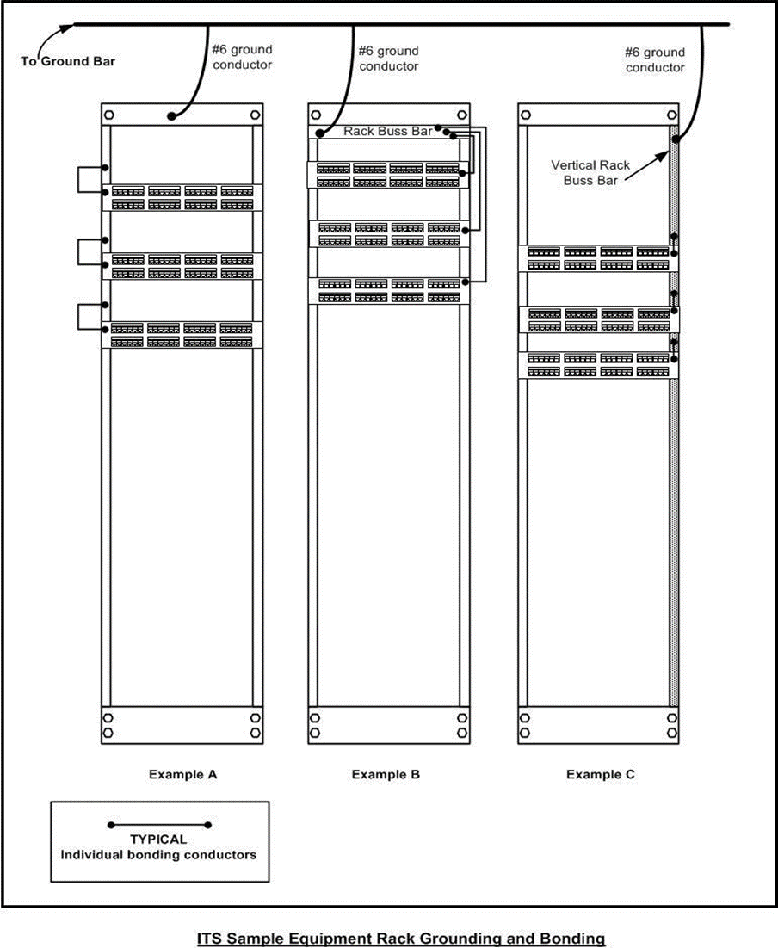

Emergency Blue Light Phone tower installation CB 1-S
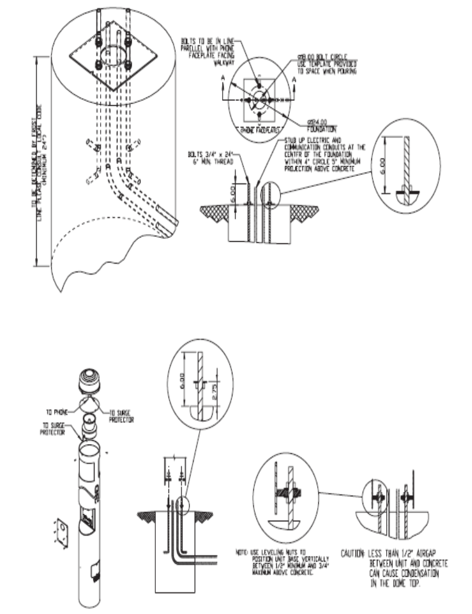

Emergency Blue Light Phone tower installation CB 1-S
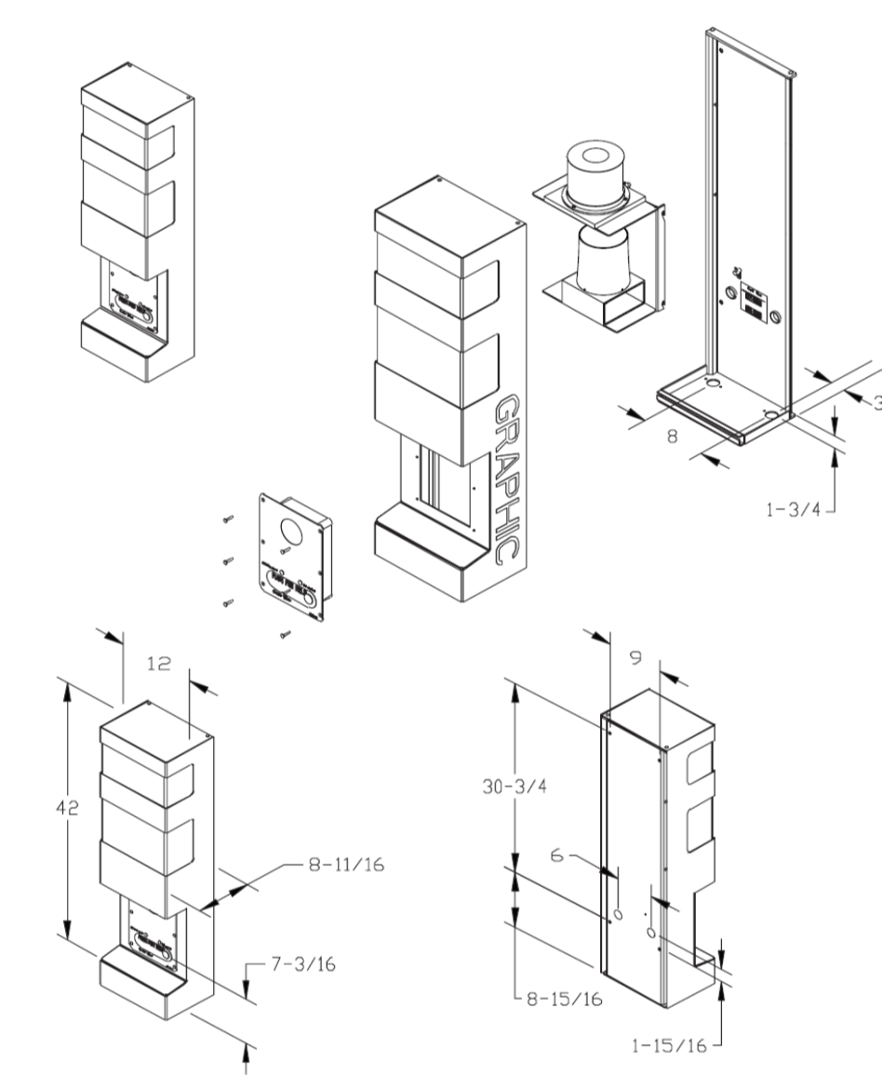

Construction As-Built Labeling example:

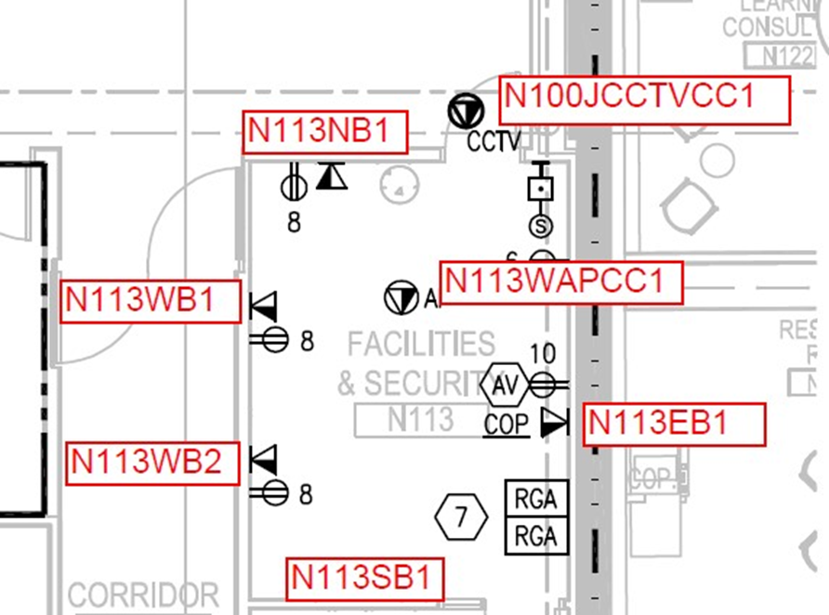

Approved Manufacture and Material List
Category 6A SYSTIMAX Solutions:
- Cable:
  - All Cat 6A cable shall be X10D U/UTP, 4 pair.
  - Blue: 1091B BL 4/23 W1000 ID# 760107094
  - White: 1091B WH 4/23 W1000 ID# 760107144
  - Yellow: 1091B YL 4/23 W1000 ID# 760107151
  - Gray: 1091B SL 4/23 W1000 ID# 7601070
  - Orange: 1091B OR 4/23 W1000 ID# 760107128
- Jacks:
  - Gray: MGS600-270 Material ID# 760092437
- Patch Panels
  - SYSTIMAX 360 Gigaspeedx10D 1100GS6 Evolve U/UTP IMVISON READY
  - 24 port: 360-IPR-1100-E-GS6-1U-24 ID# 760152587
  - 48 port: 360-IPR-1100-E-GS6-2U-48 ID# 760152595
  - 24 port Angled: 360-IPR-1100A-E-GS6-1U-24 ID# 760151324
  - 48 port Angled: 360-IPR-1100A-E-GS6-2U-48 ID# 760151779
  - Approved Fiber Optic Material:
- Cable:
  - All cables shall be manufactured by SYSTIMAX
  - All cables shall be single mode
  - All Indoor cables shall be Riser rated and Armored
  - All Outdoor cables shall be indoor/outdoor Gel free UV rated Riser
  - Indoor 24 Strand: R-024-DZ-8W-FSUYL ID# 760127373
  - Indoor 48 Strand: R-048-DZ-8W-FMUYL ID# 760127340
  - Indoor 144 Strand: R-144-DZ-8W-FMUYL ID# 760127480
  - Outdoor 48 Strand: Z-048-DS-8W-FMUBK ID# 760090309
  - Outdoor 144 Strand: R-144-LN-8W-F12BK/25D ID# 760086652
- Enclosures:
  - 1U rack mount: EPX-1U-MOD-ENC ID# 760249998
  - 2U rack mount: EPX-2U-MOD-ENC ID# 760251044
  - 4U rack mount: EPX-4U-MOD-ENC ID# 760251048
  - 1Module Wall Mount: WB2-EMT-BK-1P-MOD ID# 760248900
  - 2 Module Wall Mount: WB2-EMT-BK-2P-MOD ID# 760248901
  - 4 Module Wall Mount: WB2-EMT-BK-4P-MOD ID# 760248902
  - 8 Module Wall Mount: WB2-EMT-BK-8P-MOD ID# 760248903
- Splice Module/ Cassettes:
  - Single Mode 12 LC APC: 12 LC, Tera SPEED® SM OS2; APC, G2-SP-12LAG-PT ID# 760245960
  - Single Mode 24 LC APC: 24 LC, Tera SPEED® SM OS2; APC, G2-SP-24LAG-PT ID# 760245961
- Faceplates:
  - All faceplates shall have a label holder
  - Stainless Steel:
    - Single-Gang 1-Port M11SP-L 760072074
    - Single-Gang 2-Port M12SP-L 760072181
    - Single-Gang 3-Port M13SP-L 760072199
    - Single-Gang 4-Port M14SP-L 760072207
    - Single-Gang 6-Port M16SP-L 760072215
    - Double-Gang 8-Port M28SP-L 760100883
  - White Single Gang with Label Window:
    - Single port: M10L-262 108258427
    - 2 Port: M12L-262 108168469
    - 3 Port: M13L-262 108168501
    - 4 Port: M14L-262 108168543
    - 6 Port: M16L-262 108168584
  - White Double Gang with Label window
    - 8 port: M28L-262 108685025
  - Blank Inserts:
    - M20AP-262 107067928
  - Colors available:
    - Ivory
    - Black
    - Pro white
    - Gray
- Surface Mount Boxes:
    - 1 Port: M101SMB-B-262 107984015
    - 2 Port: M102SMB-B-262 107984056
    - 4 Port: M104SMB-A-262 107952459
    - 6 Port: M106SMB-262 107431538
  - Modular Furniture Faceplate (M-Series)
    - Opening size 4.09”x1.38”: White M13C-262 106650898
    - Opening size 4.09”x2.20”: White M14CE-E-262 N/A
    - Opening Size 3.358”x1.609”: White M14C-262 N/A
    - Opening Size adjustable 2.792-4.125”x1.7-2.79”: White M4CA-26 700191588
    - Colors available:
      - Black
      - Ivory
      - Gray
  - M106 (M-Series)
    - 2 Port: White M106FR2-262 106622251
    - 4 Port: White M106FR4-262 106622285
    - Colors available:
      - Black
      - Ivory
      - Gray
  - M108 Decora:
    - 3 Ports: White M108FR3-262 108265455
    - Colors available:
      - Ivory
      - Pro White
      - Gray
      - Black
      - Almond
- Horizontal Management:
  - All horizontal Managers shall be SYSTIMAX single sided Black
  - 2U: HTK-19-SS-2U 760072959
- Relay Racks:
  - All TR racks shall be Amco Titan Cable Management
  - All racks shall be 19” wide for network equipment mounting
  - All racks shall be a standard of 45 RU tall
  - 19”x16” Black in color: TCMR-45U-16
  - 19”x30” Black in color: TCMR-45U-30
  - Other colors available: white
  - 51 RU racks are available
- Vertical Cable Managers:
  - Al vertical managers shall be Amco Titan Cable Management
  - All vertical managers shall be doble sided
  - All vertical managers shall have front and back doors
  - All vertical managers shall be 45RU tall
  - All managers shall be Black in color
  - Standard is 10”: TCMFD-45U-116
  - 51 RU is available
- Powered Fiber Material:
  - All powered fiber cable shall be single mode indoor outdoor rated
  - All powered fiber shall be a minimum of 4 strands
  - Copper electrical gauge size is determined by the distance of the installation sizes available are:
    - 12 AWG
    - 4 strand SM with 12 AWG: PFC-S04L12
    - 2 port 60-Watt POE extender: PFU-P-C-O-060-02
    - OSP cat 6A patch cord : PCOSP-6AU-BK CO15582-01Fxxx
    - Liquid tight cord grips: Heyco® M4344GBH
    - Power Express Shelf: PFP-PX-S1
    - 8 port module: PFP-PX-8M
    - 1 RU Rectifier: PFP-SPS-S1 42Vdc to 58Vdc output
    - Rectifier power cords: 110 L5-20P plug or 220 L6-20P plug
    - Controller: PFP-SPS-C1
    - 4 Port Fiber Trans/ Midspan 1RU: Altronix NetwaysP4P

